Lecture 10 Welcome to CS-677 A1!

Instructor: Eugene Pinsky

[epinsky@bu.edu](mailto:epinsky@bu.edu)

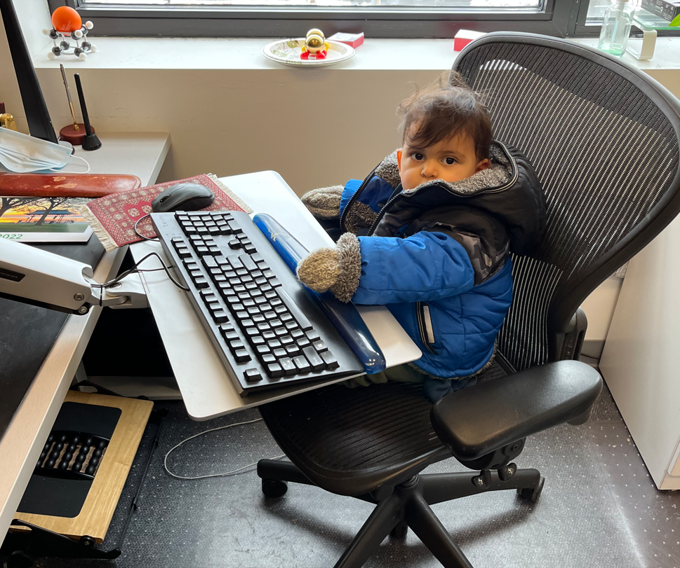

Teaching Assistants:

1. Pranjal Ekhande [pekhande@bu.edu](mailto:pekhande@bu.edu)
2. Nahush Bhamre [nahush@bu.edu](mailto:nahush@bu.edu)
3. Pete the Repeat [pete@parrot.bird](mailto:parrot@parrot.bird)

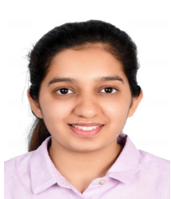

Homework #10 (due Wed 11:59:59)

* Naïve Bayesian, Discriminant Classifiers, quiz #4

Final exam: May 8, Wednesday (9 am – 11)

Last day of class: April 25 Thursday (Presentations 4-5 powerpoint slides)

Project submission (May 1)

1. 15-20 slides or description
2. code
3. video recording (Kaltura) – 5-8 minutes

March 28, April 4, 11, 18, 25

Projects:

* present on the last day of the class
* 